This submission template is a convenient document for you to provide the screenshots and explanations for Lab 3, and is intended to be used in conjunction with the Lab 3 Instructions document. The instructions document illustrates how to correctly execute each SQL construct, explains important theoretical and practical details, and contains the complete set of instructions on how to complete this lab.

**Name**: Scott Kaeneman

**Date:** 5/23/2018

Note: Section One in the lab instructions is for your benefit, to teach you by example how to complete the exercises in Section Two. It is not necessary, however, to submit the screenshots for Section One.

**SECTION TWO**

2. CREATE TABLE/ALTER TABLE commands

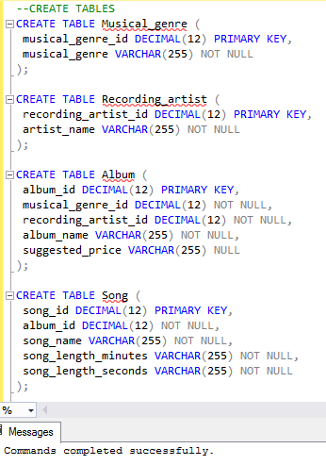

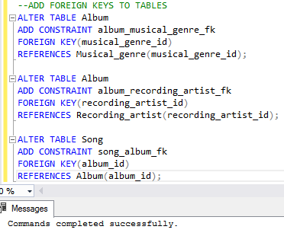

4. INSERT INTO commands

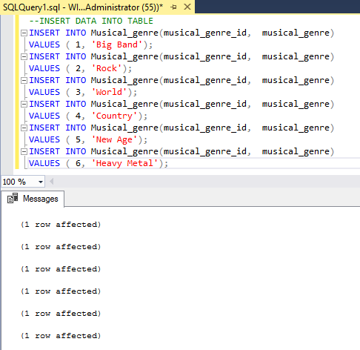

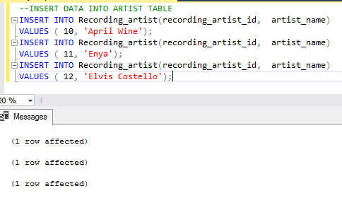

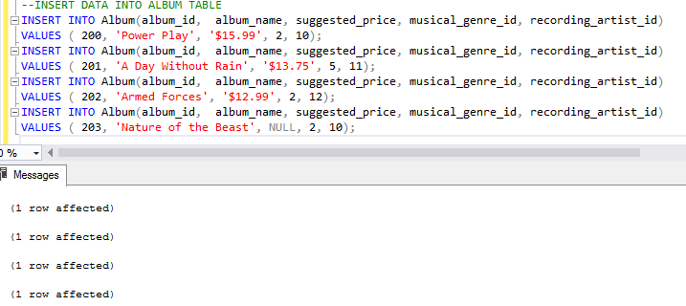

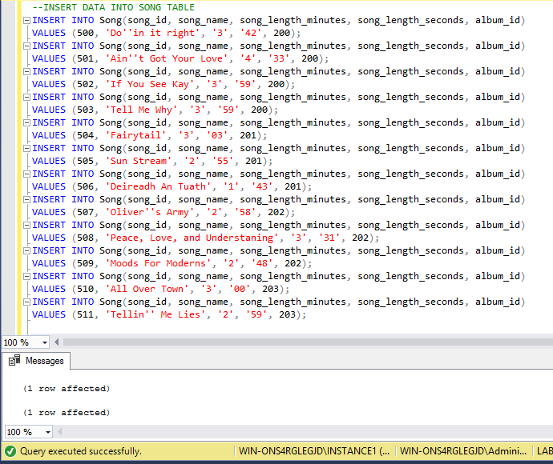

6. Counting query execution

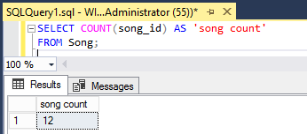

8. Two queries execution

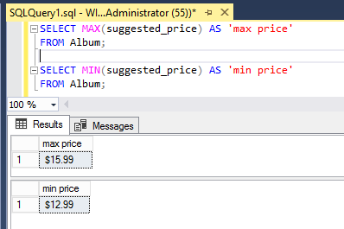

9. Different treatment explanation

Since the value is NULL for the suggested_price column of the “Nature of the Beast” record the MIN and MAX aggregate functions will therefore ignore the null value and process only those values that exist.

11. Query execution

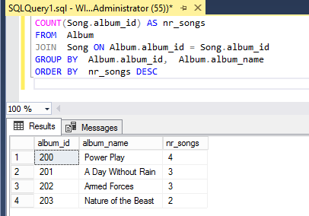

13. Query execution

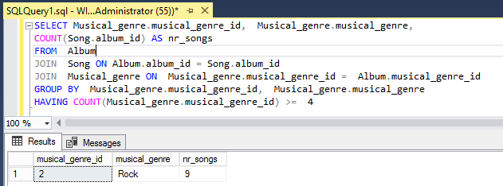

15. Query execution

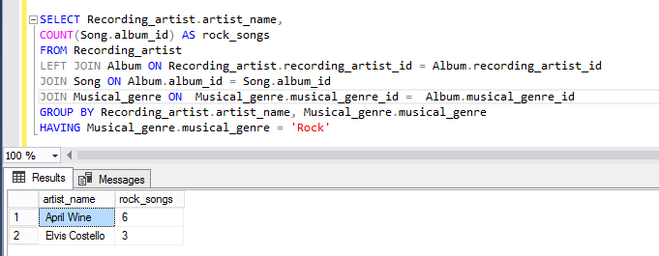

Your lab submission will be evaluated according to the following rubric.

|  |  |  |
| --- | --- | --- |
|  | **Letter Grade** | **Qualities Demonstrated by the Lab Submission** |
| **Correctness, completeness, and constitution**  **Measures the correctness and completeness of the results, and the quality of the constitution of the SQL constructs** | A+ ➔ 100 | The results and explanations are entirely complete and correct for all steps. There are absolutely no technical or other errors present. There is no known way to improve the logic and makeup of any of the SQL constructs. |
| A ➔ 96 | One insignificant technical or other error is present, but otherwise the results and explanations are entirely complete and correct for all steps. Excluding the insignificant error, there is no known way to improve the makeup of any of the SQL constructs. |
| A- ➔ 92 | One or two consequential technical or other errors are present, but otherwise the results and explanations are entirely complete and correct for all steps. Excluding the one or two errors, there is no known way to improve the makeup of any of the SQL constructs. |
| B+ ➔ 88 | A few steps have significantly incomplete or incorrect results or explanations. The results and explanations are complete and correct for the remainder of the steps. The logic and makeup of most SQL constructs are sound. |
| B ➔ 85 | A few steps have significantly incomplete or incorrect results or explanations. The results and explanations are mostly complete and correct for the remainder of the steps, with the exception of a few insignificant technical or other errors. The logic and makeup of most SQL constructs are sound. |
| B- ➔ 82 | About ¼ of the steps have significantly incomplete or incorrect results or explanations. The results and explanations are complete and correct for the remainder of the steps. The logic and makeup of at least ¾ of the SQL constructs are sound. |
| C+ ➔ 78 | About ¼ of the steps have significantly incomplete or incorrect results or explanations. The results and explanations are mostly complete and correct for the remainder of the steps, with the exception of a few insignificant technical or other errors. The logic and makeup of at least ¾ of the SQL constructs are sound. |
| C ➔ 75 | About half of the steps have significantly incomplete or incorrect results or explanations. The results and explanations are complete and correct for the remainder of the steps. The logic and makeup of at least half of the SQL constructs are sound. |
| C- ➔ 72 | About half of the steps have significantly incomplete or incorrect results or explanations. The results and explanations are mostly complete and correct for the remainder of the steps, with the exception of a few insignificant technical or other errors. The logic and makeup of at least half of the SQL constructs are sound. |
| D ➔ 67 | About ¾ of the steps have significantly incomplete or incorrect results or explanations. The results and explanations are complete and correct for the remainder of the steps. The logic and makeup of at least ¼ of the SQL constructs are sound |
| F ➔ 0 | All or almost all of the steps have incomplete or incorrect results or explanations. The logic and makeup of all or almost all of the SQL constructs are unsound. |